**Game You**

**Partner Meeting**

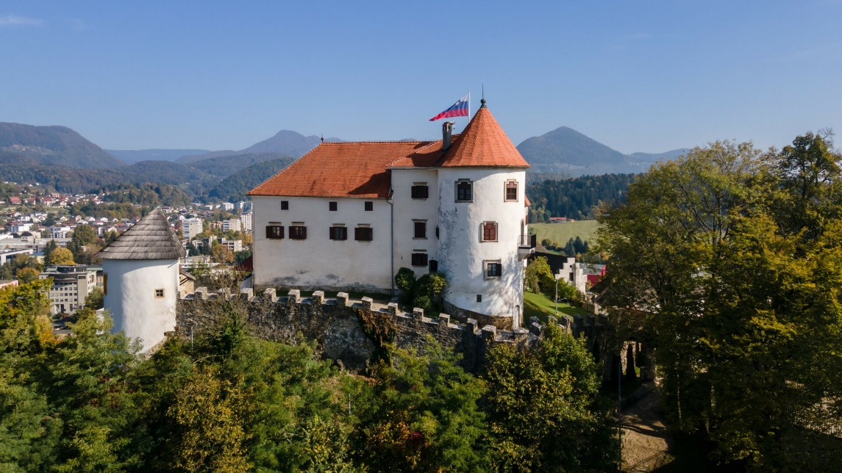

**Travel Guide to Velenje (SI) for Partners**

**Meeting from 24/10/2023 to 28/10/2023**

**Airports Close to Velenje**

* **Ljubljana_SI** (Airport Jožeta Pučnika/Brnik) – 77 km
* **Trieste_IT** (Friuli Venezia Giulia Airport) – 200 km
* **Venice_IT** (Marco Polo) – 307 km
* **Graz_AT** (Flughafen Graz) – 136 km
* **Zagreb_CRO** (Franjo Tuđman) – 160 km

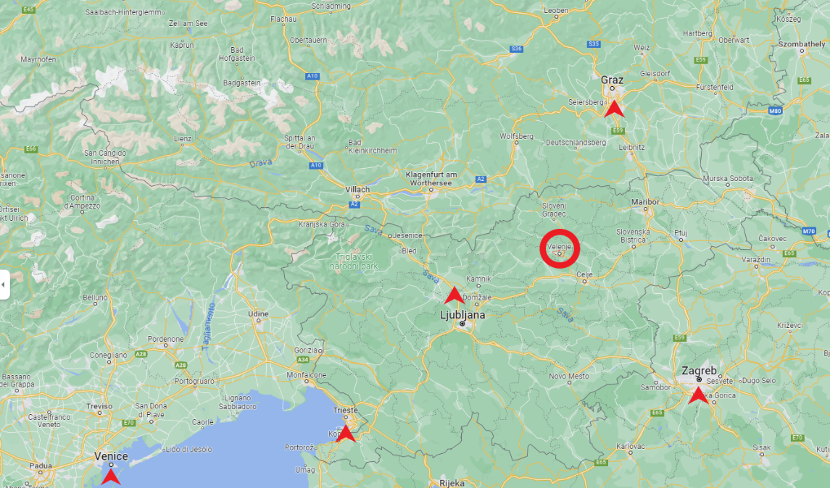

Airport in Ljubljana is of course the closest one, but even though this is the main airport in Slovenia it is not really a big one and it is usually more expensive than other options. Therefore, partners are encouraged to look at the other airports nearby, that are usually cheaper even combined with the transport to the desired location.

**Options from the Airport to Velenje**

**GoOpti**

What we in Slovenia usually do, when we need to travel to the airport and back is, that we order a service called GoOpti. It is some kind of a taxi service that is specialized to take people to the airports and back. It comes with little to no complications; it is the fastest and the cheapest one. It can pick you up at the common pick-up point (directly at the airport or city) or where you order it. They usually come with van, which has enough place for quite some luggage.

Here is the link to the page: <https://www.goopti.com/en/>

**Bus**

Public transport in Slovenia is a bit of a chaos and it takes a lot of time. We do not recommend it, but if you are feeling adventurous, … and it is also NOT way cheaper than the option mentioned above.

At first, you can take **FlixBus:** <https://global.flixbus.com/>, from any city that you land in, but it can only take you to Ljubljana (Venice, Trieste) or Maribor (Zagreb, Graz), where you have to switch to Local Bus Provider or Train.

*Please not that you still have to take taxi (or a bus if you land in Slovenia: <https://www.lju-airport.si/sl/prevoz/avtobus/> from the airport to the bus station in Ljubljana, Graz or Zagreb. If you land in Venice or Trieste, you can hop on the FlixBus on the airport.

When you come to Ljubljana (Bus station) or Maribor (Bus station) then you have to switch to a local bus or a train.

Any bus should take you directly to Velenje Bus station, from where you have 5–10-minute walk to the place of stay.

**Local Bus Provider (Tickets and timetables):** <https://www.ap-ljubljana.si/en>(Even though it is named Ljubljana Bus Station, you can still input Maribor and it will find you buses from there)

**Train**

If you choose train, that may require some train hopping.

At first you have to get a ticket from the place of landing (IT, AT, CRO) to Ljubljana, Maribor or Celje (Recommended, but on timetables it will not be shown as final destination). Like here:  
  
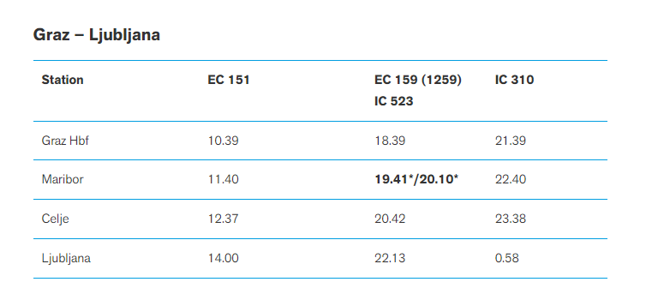

Timetables and tickets: <https://potniski.sz.si/en/> -> pick international travel.

You should see this:

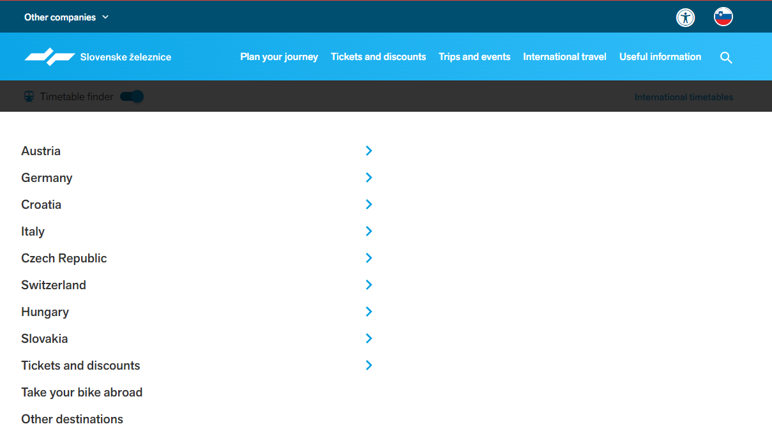

When choosing tickets, preferably pick the IC (Intercity). Trains are better and they only stop at a bigger towns. Might be a euro or two more expensive, but at least your journey with train won`t last half a day.

If you land in Trieste, you have a train there, otherwise, you still need a taxi to the train station! There is no train from Ljubljana airport to the city of Ljubljana.

When you arrive at Ljubljana, Maribor or Celje with train, the you need to purchase a ticket for a local train here: **Slovenian Rail Network:** <https://potniski.sz.si/en/> to get you to Velenje.

F.e.

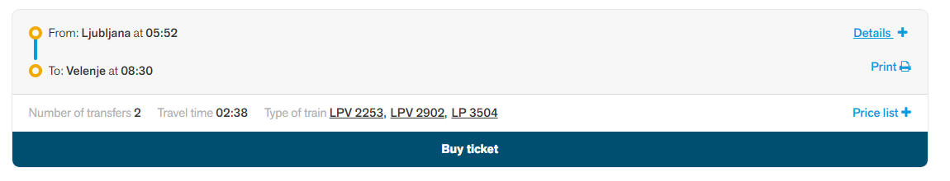

Buses and trains in Slovenia are usually on time, but are very infrequent, so if you miss it, you will have to wait quite some time for the next one.

Attention: You can come to one location by bus and then switch to train or vice versa. F.e. You can come to Ljubljana by bus and then continue by train to Velenje. Just make sure you get times right!

Buy tickets online, it will save you a lot of trouble!

*Due to current floods in Slovenia, a lot of infrastructure was damaged. Our meeting is scheduled for October, but some things may take a lot of time to be repaired, so if you plan to come to Velenje by train or bus, be prepared for last second or on the go changes.

**Rent a Car**

Since Slovenia is small and there are quite some things to see, you can always rent a car, but it is the most expensive option.

**Hotel and meeting room:** <http://www.mc-velenje.si/hotel>  
  
From Bus station:

